Partners _____________________ Your Name __________________________
____________________________ Mr. Forrest / AP Physics: 2016-17
____________________________

Electric Potential and Electric Field

Introduction: This is conceptually IMPORTANT. Read it to your lab partners before moving into the lab

Suppose for a moment that you are an electron in conducting material that is part of an electric circuit. The modern view of your life would be an interesting (but poorly understood) philosophical study. In this lab, we'll assume you are a "classical" electron and behave as a very tiny particle. When a switch closes and electric current starts to flow, what is life like? How does it feel to be in an electric field? Are you pulled (like a falling skydiver) toward one of the terminals of a battery or some other power source? Or are you pulled along - or maybe you're both pushed and pulled! Does your path seem like a multilane interstate or a one-lane rutted road? As you perform the activities in this lab, put yourself in the position of an electron moving through a circuit. The goal is to develop a better understanding and intuition for the concepts of electric resistance and resistivity, electric potential and electric field.

Materials: {Use nonmetal pushpins to start, metal pushpins when the power supply comes out??}

Instead of using wires and bulbs, this lab uses carbonized paper as the conducting paper. The resistance of various sizes and shapes of conducting paper will be measured. Later pieces of paper will be connected to a power source and the voltage at different positions on the paper will be measured. These measurements will give us a better feel for the electrical 'topography' in the paper and in real circuits.

- 1 variable output power supply - 1 digital multimeter - 2 metal pushpins & 2 non-metal pushpins
- 1 sheet of carbonized paper - 8 test leads - corkboard

Activity 1

Cut one sheet of carbonized paper into the pieces shown in the figure below. Cut carefully, as deviations from the straight lines and small variations in dimensions affect the later dimensions. NOTE that the top to bottom distance in the figure should be 20 cm. Make sure to cut all pieces out of a SINGLE sheet of paper this really matters!

A
B
C
D
E
F

Activity 2 Electrical Resistance

Place paper A on the corkboard. Firmly pin the paper down by placing a pushpin at each end of the paper. NOTE: How you pin the paper will affect your results, since the pins must be in complete contact with the carbon paper! Place each pin just inside the end of the paper, leaving enough room so that most of the pin will still touch the carbon paper but close enough to the end so distance measurements will not be greatly changed - we want the pushpins separated by 20 divisions (cm). See Figure below.
pushpin
pushpin

Also, there is sandpaper available if you feel that your metal pushpins or multimeter probes do not have adequate surface contact.

OK, this is the place where I need to tell you that this lab can be ornery. That is to say, the carbon paper can easily give inconsistent readings if you don't handle it carefully. So...

- Make sure that if the paper is bent or damaged, you cut out a new piece.
- Make sure that the pushpins make full contact with the carbon paper (not just the needle part)
- Make sure that no extra holes are in the carbon paper when you are using it (if you have any extra holes, just make a new piece.
- If any piece is used often, replace it (piece F may need this, for example).
- If your results are inconsistent, you may just need to cut out a new piece.

Set the digital multimeter to be used as an ohmmeter. Since the carbon paper is highly resistive, initially set the meter to the 2 million ohm (Ω) scale - this may be labeled as 2M. Place the probes from the meter on the top of the pushpins(if metal) or on the paper (if plastic), making sure they are parallel to the top of the pushpins so that as much area from the probe contacts the pins as possible. Make sure you press fairly firmly.

Electrical resistance of paper A: ______________________________

Note: You can expect > 10% uncertainties in the measurements that follow.

Activity 3

Complete the table below. First predict the resistance of one of the strips (base you prediction at least in part on previous measurements). Then measure its resistance and repeat the process for all the strips. Points will not be taken off for poor predictions.
TABLE 1 - Resistance of different width carbonized papers (Ω)
Paper (width)
Predicted R
Measured R
A (1 cm)
B (2 cm)
C (3 cm)
D (4 cm)
---------------

Activity 4

Plot the measured data from the table above on the graph on the next page. Also, write an equation that relates the resistance R of the strips to their widths w. Explain how you came up with the equation in the space below. When completed with the equation and graph, have your instructor check your graph and your rationale.
Equation relating R and w:

Explanation for equation:

Graph 1 - Resistance and width

Check off # 1: ___________

Activity 5

NOTE: You may cut additional pieces of carbon paper from the part of the sheet is remaining for this activity.
Develop a strategy for determining if the resistance of the paper depends on the length L of the paper. If so, record the data for this in Graph 2 shown below. Repeat activities 2-4, including coming up with an equation that relates resistance R to length L. Describe your strategy for producing an equation that relates R and L, including how you intend to collect your data. _______________________________________________________________________
____________________________________________________________________________________________
____________________________________________________________________________________________
____________________________________________________________________________________________
____________________________________________________________________________________________

Graph 2 - Resistance and length
Data for your experiments
(make sure to label this clearly)

Check off # 2: ___________
Equation relating R and L:

Activity 6

Predict the electrical resistance of paper E and paper F. Then, measure the resistances. Show the calculations leading to your predictions, noting that there is more than one way to come up with this prediction, so make sure your methodology is clear.

Paper E prediction calculations & rationale Paper F prediction calculations and rationale

Now go ahead and measure the resistances of the two papers.
TABLE 2 - Resistance of different shaped carbonized papers (Ω)
Paper (width)
Predicted R
Measured R
E (1 cm/ 2 cm)
F (1 cm/ 3 cm)

Are your data within the 10% uncertainty range (show work to calculate this) discussed earlier? _____ If not, explain how your prediction needs to be revised.

Activity 7

a) Predict the resistance between the end of the narrow section of paper E and the middle of the paper. Then, measure the resistance.

Prediction: ____________________ Ω Measurement: ____________________ Ω

Does the experiment make sense? Explain your rationale.

b) Based on your data from Activity 7 and from earlier experiments, predict the resistance between the end of the wide section of paper E and the middle of the paper. {Note: There are at least two ways to do this.}

Prediction: ____________________ Ω Measurement: ____________________ Ω
Explain the reasoning for your prediction in part 7b. How did you come up with your prediction?

Activity 8

If you were an electron traveling through the 20 cm length of a strip of carbon paper, explain in everyday words why the resistance on a wider strip would be less than the resistance of a narrower strip.
___________________________
____________________________________________________________________________________________
____________________________________________________________________________________________
____________________________________________________________________________________________
NOTE: Resistivity is a property of each kind of conducting material. The actual resistance depends on the length of the conductor, the resistivity specific for the conductor and the cross sectional area across which charges can flow. In these activities, the cross sectional area was represented by the width of the carbon paper, while in current-carrying wires it's measured in m². The formula for resistivity is:
R = ρl
A
Check off # 3: ___________

Activity 9 Electric Potential and Electric Field

In the following experiments you'll measure electric potential (sometimes called voltage or potential difference) at different positions on a piece of carbonized paper relative to some special reference position. A 6.0 V potential difference will be placed across the strip using a DC power source. Set the digital multimeter to DC voltage on the 20-V scale initially, and connect the circuit as shown in the diagram below. Clamp alligator wires from the power source to the middle of the 'body' of the pushpins.

Paper A
red wire to
V terminal
+ 6.0 V
0.0 V
black wire to
Common ground
(com)
V
Com
Multimeter

Activity 10

We'll use as a reference the voltage of the metal pushpin that is connected to the negative terminal of the power source. Touch the black ground terminal from the multimeter to the top of this same pushpin. The red lead from the multimeter (from the 'V' terminal) can be moved around by touching it to various placed on the carbon paper or to the other pushpin.

Note for data collection: For better accuracy in measurements, keep one test lead from the multimeter securely connected to the common ground pushpin (black wire) and move the other probe from the multimeter along the resistive paper.
Measure the voltage V as a function of distance x away from the reference pin. Start at the reference pin and end at the other pin. Record your measurements in the table provided and graph the data, making sure to include a line of best fit.
Graph 3: Position vs. Voltage

TABLE 3 - Voltage vs. position on paper
Position (cm)
Voltage (V)

Slope = _____________

Which way would a positive electric charge move if it could move freely through this paper? Explain your reasoning.

Which way would a negative electric charge move if it could move freely through this paper? Explain your reasoning.

Note that in both cases the change in relative charge would look the same! This is one reason why is took many years to determine which kind of charges really were moving in solid conductors.

Activity 11

Predict what would happen to the position vs. voltage graph for paper strip B as compared to strip A. After making you predictions, record your measurements and graph them out.
Graph 4: Position vs. Voltage of B
TABLE 4 - Voltage vs. position on paper B
Position (cm)
Predicted Voltage (V)
Observed
Voltage (V)

Slope = _____________
The voltage vs. position graphs for papers A and B look the same. The same potential difference is applied to equal-length strips of paper. However the resistance of paper B is about half of that of paper A. What else do you think is different about the papers when the power source is connected? (NOTE: You would need a different kind of measurement to do this, so let's just keep this a 'thought' experiment). Explain your rationale.
_________________
____________________________________________________________________________________________
____________________________________________________________________________________________

Activity 12

a) Predict what the voltage vs. position graph would look like for paper strip F. For consistency, have the wider end of piece F with the pushpin touching the black (-) terminal of the power source. Record your predictions in the following table and graph. Use a 'best fit' line to connect the points on the graph.
TABLE 5 - Voltage vs. position on paper F
Position (cm)
Predicted Voltage (V)
Observed
Voltage (V)
Again, keep the black test lead from the multimeter touching the pushpin and move the red test lead to different parts of the paper.

Graph 5: Position vs. Voltage of F
* What happens to the slope of the graph?

* Why?

COLOR CODE KEY:

b) Using a different color of pencil or pen, sketch a prediction for what the graph would look like if you flipped the orientation of piece F (so the narrow end was touching the black terminal of the power source). Now perform the experiment.
* Did the result match your prediction? ______ If not, how did it differ?

Give a brief explanation for your results about the voltage vs. position papers for papers A, B and F. When completed, get checked off by your instructor.
Check off # 4: ___________

____________________________________________________________________________________________
____________________________________________________________________________________________
____________________________________________________________________________________________
____________________________________________________________________________________________

Important Note: The steeper the voltage vs. position graph at a given point, the greater the magnitude of the electric field at that location. The electric field points 'downhill' and its magnitude along a certain axis is the negative of the ration of the change in potential (voltage or ΔV) and the change in position (Δ x). In other words it is the negative of the slope of the voltage vs. position graphs: Ex = - ΔV/Δx. The negative sign shows that the electric field is positive in the direction of decreasing electric potential. This is because early physicists defined electric field in terms of how a positive charge would move.

Activity 13

Perform this activity with paper F, and have the orientation as you left in Activity 12, with the narrow part of the paper touching the black terminal of the power source.

Make measurements that allow you to calculate the electric field at different positions on the paper. Before making these measurements, carefully consider where to measure in order to get the most accurate value for the electric field - recall this is a measurement of slope. Note that you may place either lead from the voltmeter at any location on the pushpins or the carbon paper to help you.

Calculated electric field in paper about 2 cm from the left pushpin = _________________________ Volts/meter
* Data (voltage and positions) and calculation:

Calculated electric field in paper about 2 cm from the right pushpin = _________________________ Volts/meter
* Data (voltage and positions) and calculation:

Do your data agree with the graph you drew in Activity 12b? _______ If not, explain why.

Activity 14

Compare the relative magnitudes of the electric force exerted by the electric field on electrons when at positions A and B in Activity 15 graph (a) on the next page. Note that 15(a) represents a uniform field.

Repeat the instructions above for the graph15 (b). Explain your reasoning.

Now compare the electric force exerted by the electric field on a positive charge at position A in graph 15(a) compared to the electric force exerted by the field on a negative charge of the same magnitude at the same location.
Make sure your explanation refers both to magnitude and direction of the force.

Activity 15

The voltage at various positions along pieces of conducting paper are shown for four situations (a-d) below. For each of these, indicate the relative magnitude and direction of the electric field at positions A and B with an arrow below the graph. Situation (a) is solved for you as an example.

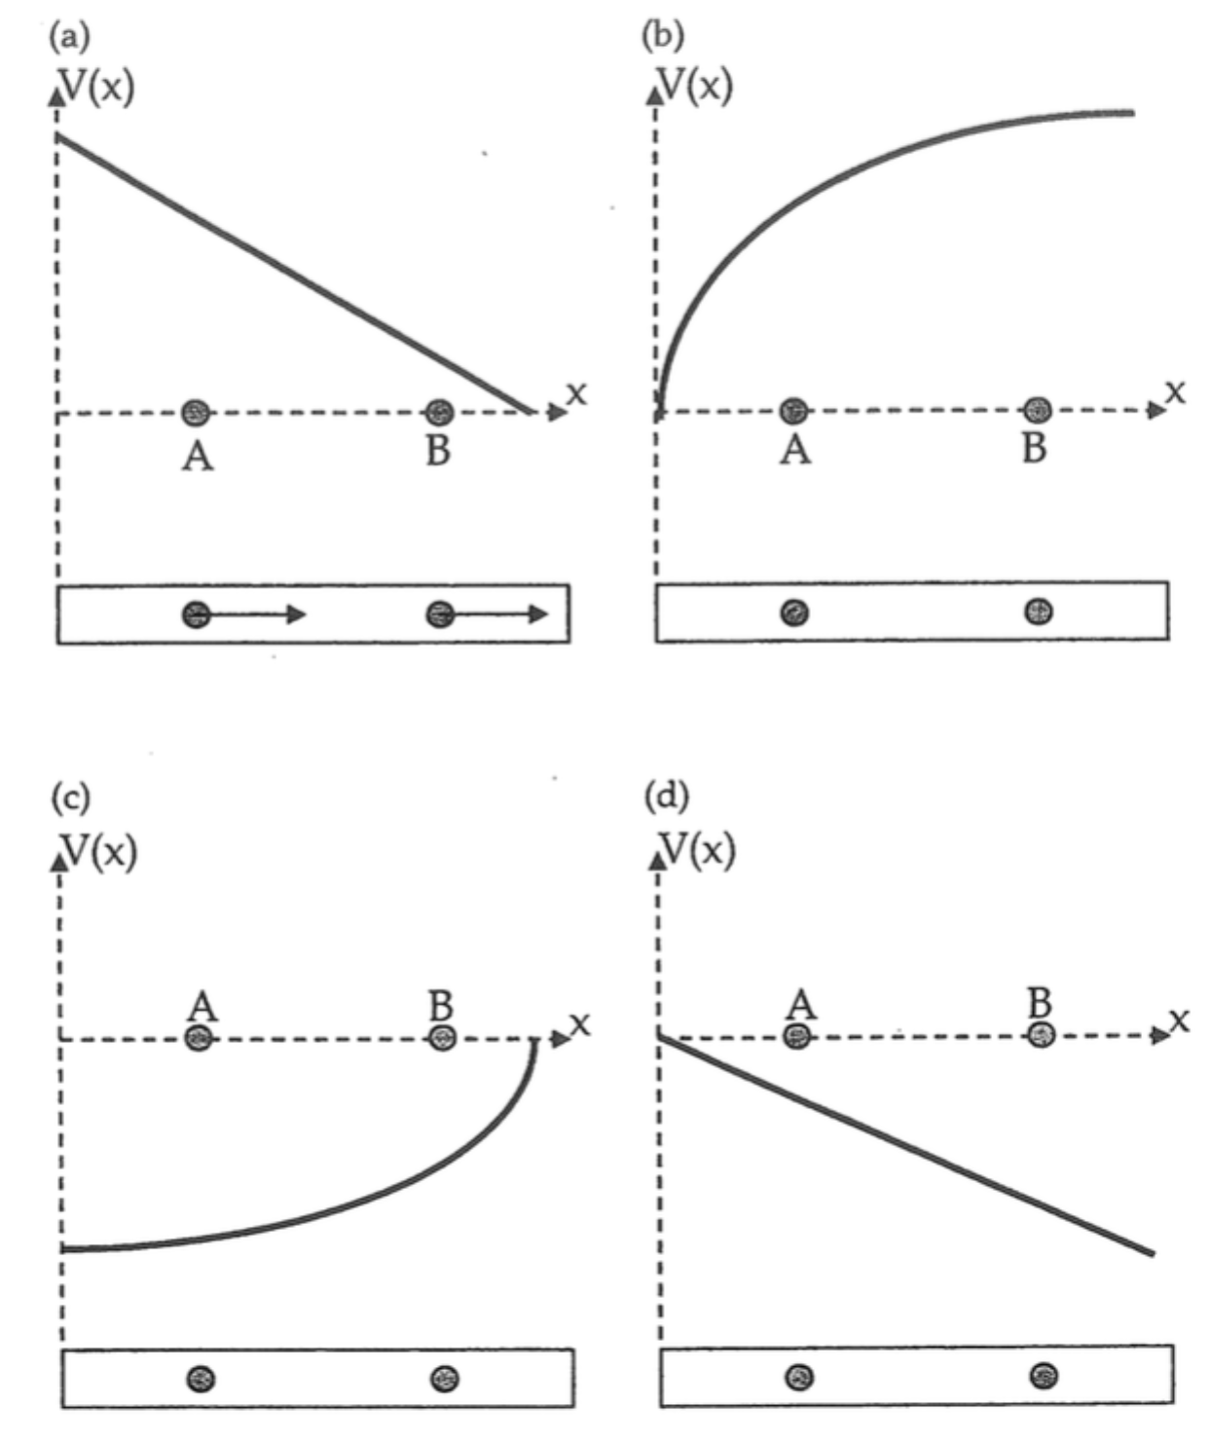

Thinker question: If graph (a)'s slope represents the electric field for paper B then what could be done to make the slope of the graph steeper and why would this change the slope?

Activity 16

Connect paper A as shown below. Note the four locations on the paper (I - IV), each being 6.67 cm apart.

Paper A
red wire to
positions II - IV
+ 6.0 V
0.0 V
black wire to
position I
initially
V
Com
Multimeter
I
II
III
IV

Predict the voltage reading under the following conditions.

Prediction (V): Observed value (V):
Black wire at I, red wire at II ___________ ___________
Black wire at I, red wire at III ___________ ___________
Black wire at I, red wire at IV ___________ ___________
Black wire at III, red wire at IV ___________ ___________
Black wire at II, red wire at III ___________ ___________

Would the values have changed if you used paper B? ____________
Check off # 5: ___________
Would the values have changed if you changed the voltage? ____________

Would the values have changed if you used paper F? ____________

Summary

The resistance of equally thick and equally long strips of conductor depends on the width of the conductor in the following manner:

The resistance of equally thick and equally wide strips of conductor depends on the length of the conductor in the following manner:

The magnitude of the electric field at a given point depends on the variation of the voltage in the following way:

The voltage in a uniform conductor increases or decreases uniformly when a potential difference is placed across the ends of the conductor. A positive charge that is free to move in the conductor will "roll" toward a region of ________ potential. A negative charge will "roll" in the conductor to a region of __________ potential.
The electric field in a conductor points _______hill in the same direction that a ______________ charge tends to roll.

