CST Released Questions - 2009

MULTIPLE CHOICE

1. 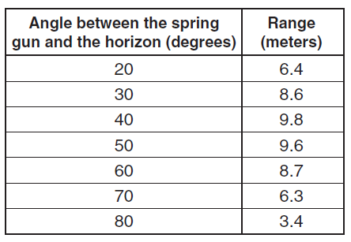
The table shows the results of an experiment with a projectile fired from a spring gun. The results could be most easily interpreted if the data were
a. | entered into a spreadsheet.
b. | put into a database.
c. | plotted in a histogram.
d. | plotted as range vs. angle.

ANS: D PTS: 1 STA: PHIE1.A NOT: Released 2006

2. To create real-time graphs of an object’s displacement versus time and velocity versus time, a students would need to use a
a. | motion sensor.
b. | low- g accelerometer.
c. | potential difference probe.
d. | force probe.

ANS: A PTS: 1 STA: PHIE1.A NOT: Released 2006

3. A students does an experiment to measure the acceleration of a falling object, which is 9.8 . The student obtains an experimental value of 14.6 . The reason for this variation is most likely due to
a. | human error.
b. | air resistance.
c. | local flucuations in gravity.
d. | the mass of the object.

ANS: A PTS: 1 STA: PHIE1.B NOT: Released 2003

4. 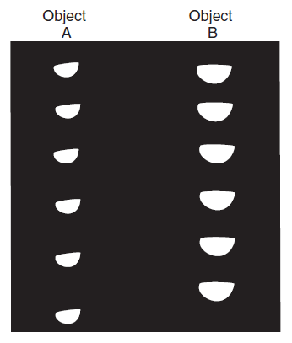
The picture shows two objects that were dropped and recorded with a stroboscopic camera. The best explanation for the results is that object A
a. | has less air resistance.
b. | was dropped from a greater height.
c. | has a greater mass.
d. | accelerated more slowly.

ANS: A PTS: 1 STA: PHIE1.C NOT: Released 2003

5. A student applied a constant force to a toy truck. A graph of the truck’s movement is show below.
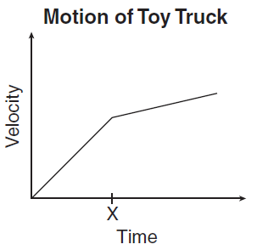
Which of the following could best explain the change in velocity at time X?
a. | The truck’s momentum became greater than its inertia.
b. | The truck went from moving in a straight path to moving in a curved path.
c. | The truck began traveling up at a slightly sloped surface.
d. | The truck went from rolling on a rough surface to rolling on a polished surface.

ANS: C PTS: 1 STA: PHIE1.D NOT: Released 2007

6. A students wires a series circuit that includes a block of rubber and a light bulb. She states that she does not expect the light bulb to light up when current is applied to the circuit. Which of the following best describes her statement?
a. | It is a conclusion based on observed data about electrical phenomena.
b. | It is a hypothesis based on knowledge of the theory of electrical phenomena.
c. | It is a procedure based on her hypothesis about electrical phenomena.
d. | It is a theory based on her observations of electrical phenomena.

ANS: B PTS: 1 STA: PHIE1.F NOT: Released 2004

7. A student attempts to measure the mass of a brick by measuring the force required to accelerate it at 1 on a level surface. the froce required is 2N, and the student concludes that the brick has a mass of 2 kg. A balance shows that the mass of the brick is really 1.5 kg. The experimental error is most likely due to
a. | gravity.
b. | work.
c. | friction.
d. | inertia.

ANS: C PTS: 1 STA: PHIE1.J NOT: Released 2005

8. The graph below was presented to a science class.
An accurate analysis of the data in the graph could be used to support a hypothesis that the United States has
a. | become increasingly dependent on imported petroleum.
b. | become more efficient in the conservation of petroleum.
c. | regulated production by prohibiting companies from producing petroleum.
d. | increased its reserves while consuming imported petroleum.

ANS: A PTS: 1 STA: PHIE1.M NOT: Released 2008

9. How much time will it take for a person to walk the length of a football field (100 yard) at a constant speed of 5?
a. | 20 seconds
b. | 33 seconds
c. | 60 seconds
d. | 166 seconds

ANS: C PTS: 1 STA: PH1.A NOT: Released 2003

10. A ball is dropped from rest from a height 6.0 meters above the ground. The ball falls freely and reaches the ground 1.1 seconds later. What is the average speed of the ball?
a. | 5.5
b. | 6.1
c. | 6.6
d. | 11

ANS: A PTS: 1 STA: PH1.A NOT: Released 2005

11. An object moves away from a motion detector with a constant speed. Which graph best represents the motion of the object?
a. | 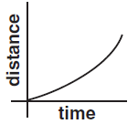
b. | 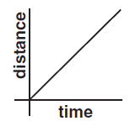
c. | 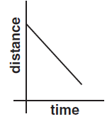
d. | 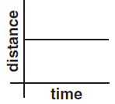

ANS: B PTS: 1 STA: PH1.A NOT: released 2007

12. A 10-newton force and a 15-newton force are acting from a single point in opposite directions. What additional force must be added to produce equilibrium?
a. | 5 N acting in the same direction as the 10-N force
b. | 5 N acting in the same direction as the 15-N force
c. | 10 N acting in the same direction as the 10-N force
d. | 25 N acting in the same direction as the 15-N force

ANS: A PTS: 1 STA: PH1.B NOT: Released 2004

13. A student holds a book at rest in an outstretched hand. The force exerted on the book by the student is equal to the book’s
a. | mass.
b. | weight.
c. | volume.
d. | density.

ANS: B PTS: 1 STA: PH1.B NOT: Released 2006

14.
The graph below shows the velocity of a car that is moving in a straight line.
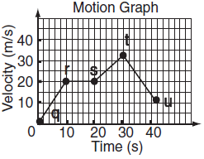
During which of the following intervals are forces on the car balanced?
a. | q to r
b. | r to s
c. | s to t
d. | t to u

ANS: B PTS: 1 STA: PH1.B NOT: Released 2008

15. 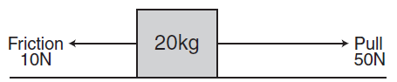
The figure shows a block that is being pulled along the floor. According to the figure, what is the acceleration of the block?
a. | 2
b. | 3
c. | 4
d. | 6

ANS: A PTS: 1 STA: PH1.C NOT: Released 2003

16. A 50-kg child on a skateboard experiences a 75-N force as shown. What is the expected acceleration of the child?
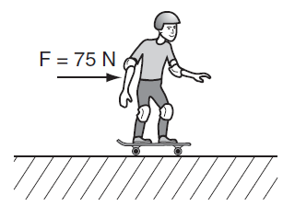
a. | 0.67
b. | 1.50
c. | 6.70
d. | 25.00

ANS: B PTS: 1 STA: PH1.C NOT: Released 2006

17.
A soccer player kicks a 0.5-kilogram stationary ball with a force of 50 newtons. What is the force on the player’s foot?
a. | 0 N
b. | 25 N
c. | 50 N
d. | 100 N

ANS: C PTS: 1 STA: PH1.D NOT: Released 2003

18.
A student in a lab experiment jumps upward off a common bathroom scale as the lab partner records the scale reading. What does the lab partner observe during the instant the student pushes off?
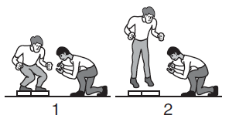
a. | The scale reading will remain unchanged during the entire time the student is in contact with the scale.
b. | The scale reading will increase momentarily then will decrease as the student is moving upward from the scale.
c. | The scale reading will increase during the entire time the student is in contact with the scale.
d. | The scale reading will decrease momentarily then will increase as the student is moving upward from the scale.

ANS: B PTS: 1 STA: PH1.D NOT: Released 2005

19. What event will produce the greatest increase in the gravitational force between the two masses?
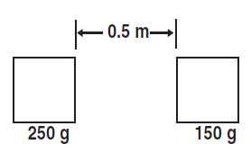
a. | doubling the large mass
b. | doubling the distance between the masses
c. | reducing the small mass by half
d. | reducing the distance between the masses by half

ANS: D PTS: 1 STA: PH1.E NOT: Released 2006

20. Objects on the surface of Earth experience a large downward force although the universal gravitational constant is very small. Which of the following best explains this phenomenon?
a. | Objects on Earth’s surface exert a gravitational pull as strong as Earth’s, regardless of the gravitational constant.
b. | The universal gravitational constant only describes relationships between small objects in outer space.
c. | Earth’s mass is large enough that its gravity remains strong even when multiplied by a small constant.
d. | The universal gravitational constant increases in proportion with the mass of an object.

ANS: C PTS: 1 STA: PH1.E NOT: Released 2008

21. A communication satellite is in a circular orbit around Earth. If the speed of the satellite is constant, the force acting on the satellite
a. | is zero.
b. | is decreasing.
c. | points toward the center of Earth at all times.
d. | points in the direction that the satellite is moving.

ANS: C PTS: 1 STA: PH1.F NOT: Released 2004

22. A satellite that is moving in a circular orbit around Earth and maintaining a constant speed will experience a
a. | changing gravitational force toward Earth.
b. | net gravitational force toward Earth.
c. | changing acceleration away from Earth.
d. | net acceleration away from Earth.

ANS: B PTS: 1 STA: PH1.F NOT: Released 2007

23.
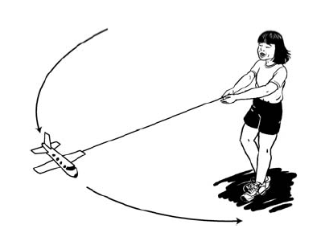
The picture shows the circular path of a toy plane being swung around on a string. What path would the toy take if the string broke?
a. | 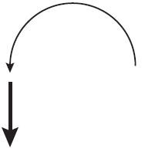
b. | 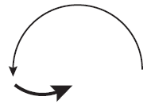
c. | 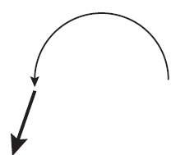
d. | 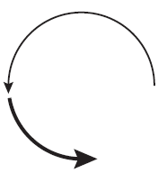

ANS: A PTS: 1 STA: PH1.G NOT: Released 2004

24. A ball on a rope swings around a vertical pole.
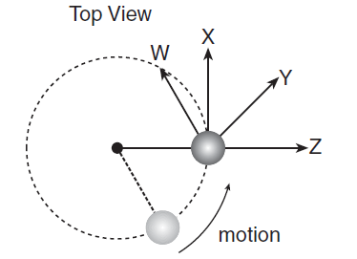
In which direction will the ball fly if released at the location shown?
a. | W
b. | X
c. | Y
d. | Z

ANS: B PTS: 1 STA: PH1.G NOT: Released 2007

25. A small car is being driven in a circular path at constant speed on a horizontal surface. What is the direction of the frictional force that keeps the car from skidding as it travels along this path?
a. | opposite the direction of the velocity of the car
b. | in the same direction as the velocity of the car
c. | toward the center of the circle
d. | outward from the center of the circle

ANS: C PTS: 1 STA: PH1.G NOT: Released 2008

26. A 2.0-kilogram mass is moving with a speed of 3.0 . What is the kinetic energy of the mass?
a. | 1.5 J
b. | 6 J
c. | 9 J
d. | 12 J

ANS: C PTS: 1 STA: PH2.A NOT: Released 2003

27. Three objects move with a velocity of 1 . What is the total kinetic energy of the system?
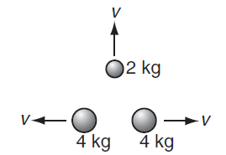
a. | 1 J
b. | 2 J
c. | 5 J
d. | 10 J

ANS: C PTS: 1 STA: PH2.A NOT: Released 2005

28. What is the kinetic energy of an object with a mass of 10 kilograms traveling at a speed of 10 meters per second? Assume no other forces act upon the object.
a. | 100 J
b. | 500 J
c. | 1000 J
d. | 50,000 J

ANS: B PTS: 1 STA: PH2.A NOT: Released 2007

29. What is the kinetic energy of a 2-kg toy car moving at a velocity of 5 ?
a. | 5 J
b. | 10 J
c. | 25 J
d. | 50 J

ANS: C PTS: 1 STA: PH2.A NOT: Released 2008

30. A 50-kilogram firefighter is on a ladder 10 meters above the ground. When the firefighter descends to 5 meters above the ground, the firefighter’s gravitational potential energy will decrease by
a. | 0.194 Joules.
b. | 5.10 Joules.
c. | 490 Joules.
d. | 2450 Joules.

ANS: D PTS: 1 STA: PH2.B NOT: Released 2003

31.
A hydraulic lift used at an automotive repair shop raises a 1000-kilogram car two meters off of the ground. What is the potential energy given to the car?
a. | 1000 J
b. | 2000 J
c. | 9800 J
d. | 19,600 J

ANS: D PTS: 1 STA: PH2.B NOT: Released 2005

32.
A 5-kilogram mass is lifted from the ground to a height of 10 meters. The gravitational potential energy of the mass is increased by approximately
a. | 0.5 J
b. | 50 J
c. | 250 J
d. | 500 J

ANS: D PTS: 1 STA: PH2.B NOT: Released 2006

33.
A high diver steps off a diving platform that is 10 meters above the water. If no air resistance is present, during the fall there will be a decrease in the diver’s
a. | gravitational potential energy.
b. | total mechanical energy.
c. | kinetic energy.
d. | momentum.

ANS: A PTS: 1 STA: PH2.C NOT: Released 2004

34.
A 2.5-kg brick falls to the ground from a 3-m-high roof. What is the approximate kinetic energy of the brick just before it touches the ground?
a. | 75 J
b. | 38 J
c. | 12 J
d. | 11 J

ANS: A PTS: 1 STA: PH2.C NOT: Released 2005

35.
Starting from rest, a 2-kilogram block of wood slides a distance of two meters down a frictionless slope, as shown.
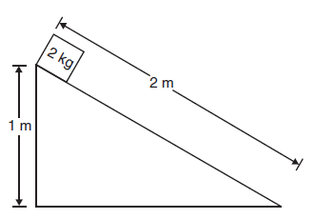
What is the approximate kinetic energy of the wooden block at the bottom of the slope?
a. | 20 J
b. | 40 J
c. | 200 J
d. | 400 J

ANS: A PTS: 1 STA: PH2.C NOT: Released 2008

36.
A child is on a sled moving down a hill at 20 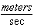. The combined mass of the sled and child is 100 kilograms. The momentum of the child and sled is
a. | 5 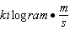
b. | 10
c. | 1000
d. | 2000

ANS: D PTS: 1 STA: PH2.D NOT: Released 2004

37.
A 70-kg skier leaves a ski jump at a velocity of 14 . What is the skier’s momentum at that instant?
a. | 5
b. | 50
c. | 98
d. | 980

ANS: D PTS: 1 STA: PH2.D NOT: Released 2006

38. What is the momentum of an asteroid that has a mass of and a velocity of ?
a. | 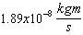
b. | 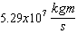
c. | 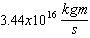
d. | 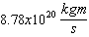

ANS: C PTS: 1 STA: PH2.D NOT: Released 2007

39. When is linear momentum conserved?
a. | when only nonlinear forces are present
b. | when more linear than nonlinear forces are in the system
c. | when internal forces exceed external forces
d. | when the net force on the system is zero

ANS: D PTS: 1 STA: PH2.E NOT: Released 2004

40. In collisions between two objects, kinetic energy is conserved only
a. | if one of the objects was initially at rest.
b. | if potential energy converts to work energy.
c. | in inelastic collisions.
d. | in elastic collisions.

ANS: D PTS: 1 STA: PH2.E NOT: Released 2007

41. A temporary force acting on a 2 kg object traveling at a velocity of 5 causes the object to slow to a velocity of 2 . What was the decrease in the momentum of the object?
a. | 4 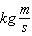
b. | 5
c. | 6
d. | 7

ANS: C PTS: 1 LOC: PH2.F NOT: Released 2008

42. 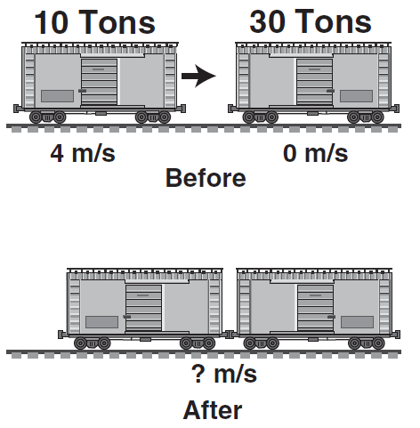
When these two freight cars of different mass collide and couple, what will be their resultant velocity?
a. | 1
b. | 2
c. | 4
d. | 8

ANS: A PTS: 1 STA: PH2.G NOT: Released 2004

43. The diagram depicts a 2-kg mass colliding with and sticking to a second box. What is the mass of the second box?
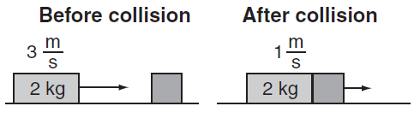
a. | 4 kg
b. | 6 kg
c. | 8 kg
d. | 9 kg

ANS: A PTS: 1 STA: PH2.G NOT: Released 2005

44. In an elastic collision, momentum is conserved, as is
a. | kinetic energy.
b. | potential energy.
c. | speed.
d. | velocity.

ANS: A PTS: 1 STA: PH2.G NOT: Released 2008

45. A cup of water at 40 °C and a cup of water at 5 °C are left on a table. Which graph correctly shows the temperature of the two cups of water as time passes?
a. | 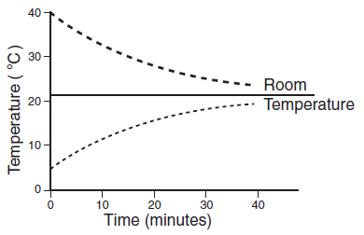
b. | 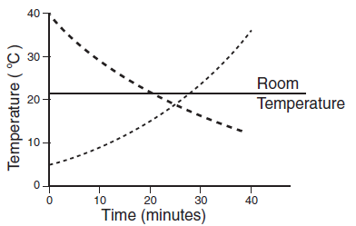
c. | 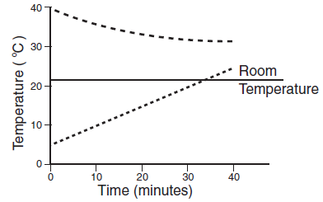
d. | 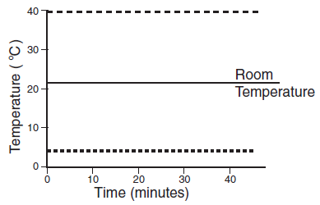

ANS: A PTS: 1 STA: PH3.A NOT: Released 2004

46. A heated gas expands, raising a piston. Which of the following describes the energy exchanges of this process?
a. | Energy is transferred to the gas by the piston, and to the piston from the heat source.
b. | Energy is transferred to the gas from the heat source, and to the raised piston from the gas.
c. | Energy is transferred to the gas in the form of heat and work done by the piston.
d. | Energy is transferred directly to the piston from the heat source.

ANS: B PTS: 1 STA: PH3.A NOT: Released 2006

47. When a steel block at 100 ºC is placed on top of a copper block at 20 ºC, the thermal energy of the copper begins to increase. Which of the following is the source of this increase in energy?
a. | the work done by the molecules within the copper
b. | the work done by the interaction of the two metals
c. | heat flowing by means of conduction
d. | heat flowing by means of radiation

ANS: C PTS: 1 STA: PH3.A NOT: Released 2008

48. An engine has an input of heat energy of 10,750 J and does 2420 J of work. Which of the following is the heat loss?
a. | 0.225 J
b. | 4.44 J
c. | 8330 J
d. | 13,170 J

ANS: C PTS: 1 STA: PH3.B NOT: Released 2005

49. A proposed ideal heat engine would run with a high temperature reservoir at 800 kelvin and a low temperature reservoir at 300 kelvin. When the engine is running, it extracts 400 joules of energy from the hot reservoir and does 250 joules of work each minute. How much energy is expelled to the low temperature reservoir each minute?
a. | 150 J
b. | 250 J
c. | 300 J
d. | 400 J

ANS: A PTS: 1 STA: PH3.B NOT: Released 2006

50.
The pressure of a gas inside a closed, rigid container will increase when the gas temperature increases. The pressure of the gas increases because the
a. | density of the gas decreases.
b. | rate of collisions of gas molecules with the surface increases.
c. | container expands in size when heated.
d. | gas molecules bond together to form more massive molecules.

ANS: B PTS: 1 STA: PH3.C NOT: Released 2003

51.
A gas in a sealed cylinder is heated. Which of the following does not increase as the gas is heated?
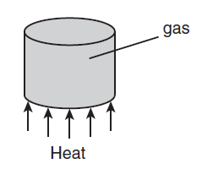
a. | the average number of gas molecules hitting the cylinder walls per second
b. | the average kinetic energy of the gas molecules
c. | the average speed of the gas molecules
d. | the average distance between the gas molecules

ANS: D PTS: 1 STA: PH3.C NOT: Released 2003

52. When a gas is heated in a closed container, the internal pressure increases. Which best describes the reason for the increase in pressure?
a. | The average kinetic energy of the gas molecules decreases.
b. | The potential energy of the gas increases.
c. | The average kinetic energy of the gas molecules increases.
d. | The potential energy of the gas decreases.

ANS: C PTS: 1 STA: PH3.C NOT: Released 2004

53.
Molecules move about in random motion within a liquid. The total internal energy of the liquid depends on all of the following except its
a. | temperature.
b. | mass.
c. | specific heat.
d. | melting point.

ANS: D PTS: 1 STA: PH3.C NOT: Released 2008

54. In which of the following processes is the order of the system increasing?
a. | shaking a jar containing separate layers of salt and pepper
b. | smashing a coffee cup with a hammer
c. | adding cold milk to a cup of hot coffee
d. | forming crystals in a solution

ANS: D PTS: 1 STA: PH3.D NOT: Released 2004

55. A container of cold water is dumped into a larger container of hot water. It is mixed and then left alone for a long time interval. The water temperature is found to
a. | randomly vary from region to region in the container.
b. | be uniform throughout the container.
c. | fluctuate at all positions in the container.
d. | be greater at the bottom of the container.

ANS: B PTS: 1 STA: PH3.D NOT: Released 2005

56.
Which of the following describes a system in which entropy is being increased?
a. | Liquid water freezes to solid ice.
b. | Air is compressed into a container.
c. | Steam is condensed to a liquid.
d. | Fuel is vaporized before burning.

ANS: D PTS: 1 STA: PH3.D NOT: Released 2008

57.
Nitrogen molecules within a glass tube are allowed to move randomly. Which figure shows the molecules in a state of greatest entropy?
a. | 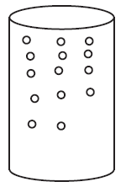
b. | 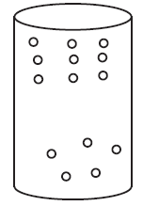
c. | 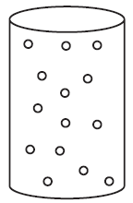
d. | 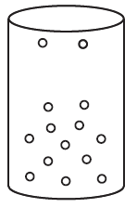

ANS: C PTS: 1 STA: PH3.E NOT: Released 2007

58. Entropy decreases when
a. | wood burns.
b. | water freezes.
c. | a snowball melts.
d. | an iron nail rusts.

ANS: B PTS: 1 STA: PH3.E NOT: Released 2007

59. A sound wave is produced in a metal cylinder by striking one end. Which of the following occurs as the wave travels along the cylinder?
a. | Its amplitude increases.
b. | Its frequency increases.
c. | It transfers matter.
d. | It transfers energy.

ANS: D PTS: 1 STA: PH4.A NOT: Released 2006

60. The graph below depicts the relationship between wave energy and wave amplitude.
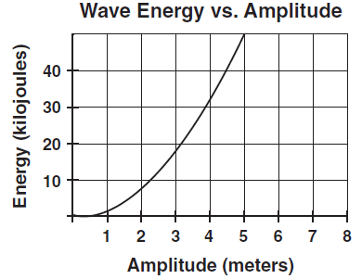
How is the energy of the wave affected if the amplitude of the wave increases from 2 meters to 4 meters?
a. | It is halved.
b. | It is doubled.
c. | It is quadrupled.
d. | It remains the same.

ANS: C PTS: 1 STA: PH4.A NOT: Released 2006

61. A radio station transmits to a receiving antenna. The radio wave sent is a
a. | sound wave.
b. | torsional wave.
c. | longitudinal wave.
d. | transverse wave.

ANS: D PTS: 1 STA: PH4.B NOT: Released 2003

62. A stretched spring attached to two fixed points is compressed on one end and released, as shown below.
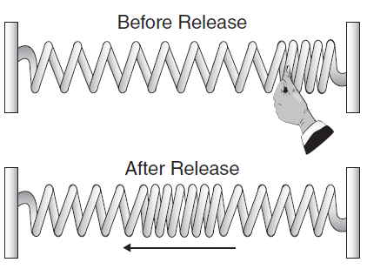
The resulting wave travels back and forth between the two fixed ends of the spring until it comes to a stop. This mechanical wave is an example of a
a. | transverse wave.
b. | longitudinal wave.
c. | superpositioned wave.
d. | refracted wave.

ANS: B PTS: 1 STA: PH4.B NOT: Released 2005

63.
One end of a horizontal string is caused to oscillate vertically while the other end is attached to a fixed object. The wave that travels along the string is an example of
a. | an electromagnetic wave.
b. | a transverse wave.
c. | a microwave.
d. | a longitudinal wave.

ANS: B PTS: 1 STA: PH4.B NOT: Released 2008

64. A sound wave traveling through a solid material has a frequency of 500 hertz. The wavelength of the sound wave is 2 meters. What is the speed of sound in the material?
a. | 250
b. | 500
c. | 1000
d. | 250,000

ANS: C PTS: 1 STA: PH4.C NOT: Released 2003

65. A tuning fork is used to produce sound waves with a frequency of 440 hertz. The waves travel through the air at 344 . What is the wavelength of the sound waves?
a. | 0.15 m
b. | 0.39 m
c. | 0.78 m
d. | 1.28 m

ANS: C PTS: 1 STA: PH4.C NOT: Released 2005

66.
A student shakes the end of a rope with a frequency of 1.5 Hz, causing waves with a wavelength of 0.8 m to travel along the rope. What is the velocity of the waves?
a. | 1.9
b. | 1.6
c. | 1.2
d. | 0.53

ANS: C PTS: 1 STA: PH4.C NOT: Released 2006

67. What is the wavelength of a 264 Hz sound wave when the speed of sound is 345 ?
a. | 0.77 m
b. | 1.31 m
c. | 6.09 m
d. | 9.11 m

ANS: B PTS: 1 STA: PH4.C NOT: Released 2007

68. Astronauts on the Moon would not be able to hear a landslide because
a. | the lunar dust deadens sounds.
b. | intensive sunlight destroys sound waves.
c. | the magnetic field of the Moon is too weak to carry sound.
d. | air molecules on the Moon are too far apart to carry sound.

ANS: D PTS: 1 STA: PH4.D NOT: Released 2004

69. Sound waves cannot carry energy through
a. | water.
b. | air.
c. | a mirror.
d. | a vacuum.

ANS: D PTS: 1 STA: PH4.D NOT: Released 2007

70. Where does visible light fall on the electromagnetic spectrum?
a. | between x-rays and gamma rays
b. | between short-wave radio and television
c. | between infrared and ultraviolet
d. | between microwaves and infrared

ANS: C PTS: 1 STA: PH4.E NOT: Released 2007

71. In a vacuum, radio waves, visible light, and x-rays all have the same
a. | wavelength.
b. | speed.
c. | frequency.
d. | energy.

ANS: B PTS: 1 STA: PH4.E NOT: Released 2008

72. Objects appear different in size and shape in a container of water due to
a. | refraction of the light waves.
b. | interference of the water and light waves.
c. | polarization of the light waves.
d. | diffraction of the light waves.

ANS: A PTS: 1 STA: PH4.F NOT: Released 2003

73. An engineer in a moving train blows the train’s horn. The train is moving away from a person standing on the ground. Compared to the frequency of the sound that the engineer hears, the person standing on the ground hears a sound with
a. | the same wavelength.
b. | more variation in tone.
c. | greater amplitude.
d. | a lower frequency.

ANS: D PTS: 1 STA: PH4.F NOT: Released 2004

74. In this circuit, what is the current through the 2-ohm resistor?
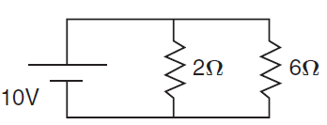
a. | 0.2 A
b. | 0.8 A
c. | 5.0 A
d. | 8.0 A

ANS: C PTS: 1 STA: PH5.A NOT: Released 2003

75. 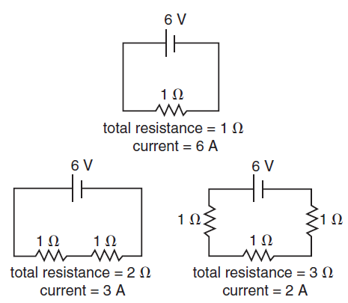
How many amperes of current will flow when four 1-ohm resistors are in this series circuit?
a. | 0.5 amperes
b. | 1.0 amperes
c. | 1.5 amperes
d. | 2.0 amperes

ANS: C PTS: 1 STA: PH5.A NOT: Released 2005

76.
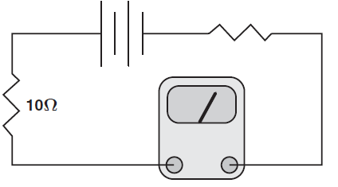
In the circuit shown above, the meter registers 1.5 amperes. The voltage across the 10.0-ohm resistor is about
a. | 1.5 C
b. | 6.7 V
c. | 8.5 V
d. | 15.0 V

ANS: D PTS: 1 STA: PH5.B NOT: Released 2003

77. 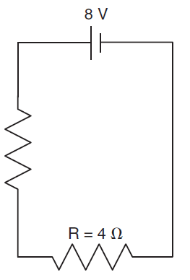
What is the current through the battery?
a. | 1 A
b. | 2 A
c. | 4 A
d. | 8 A

ANS: A PTS: 1 STA: PH5.B NOT: Released 2005

78. A 9-V battery is connected to a light bulb with a resistance of 3 . What is the current in the circuit?
a. | 27 A
b. | 3.0 A
c. | 1.0 A
d. | 0.3 A

ANS: B PTS: 1 STA: PH5.B NOT: Released 2006

79. An electric appliance draws 1.5 amperes of current when it is connected to a 24-volt source. What is the resistance of this appliance?
a. | 0.063 ohm
b. | 11 ohms
c. | 16 ohms
d. | 54 ohms

ANS: C PTS: 1 STA: PH5.B NOT: Released 2007

80. 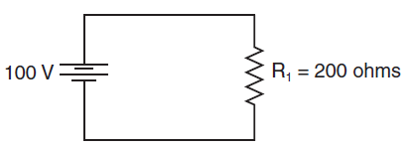
How much power is dissipated by the resistor in the circuit above?
a. | 25 watts
b. | 50 watts
c. | 100 watts
d. | 800 watts

ANS: B PTS: 1 STA: PH5.C NOT: Released 2007

81. Superconductors are materials that appear to exhibit no resistance. Therefore, electrons passing through a superconductor will
a. | generate no current.
b. | generate no heat.
c. | increase the current’s power.
d. | decrease the electrons’ charges.

ANS: B PTS: 1 STA: PH5.C NOT: Released 2008

82. A transistor circuit is used as an amplifier. When a signal is applied to the input of the transistor, the output signal is
a. | a smaller amplitude.
b. | an equal amplitude.
c. | a larger amplitude.
d. | zero amplitude.

ANS: C PTS: 1 STA: PH5.D NOT: Released 2005

83. Two oppositely charged particles are held in place near each other. When the particles are released, they will most likely
a. | accelerate away from each other.
b. | accelerate toward each other.
c. | rotate in a clockwise direction.
d. | rotate in a counterclockwise direction.

ANS: B PTS: 1 STA: PH5.E NOT: Released 2007

84. A metal bar magnet has a magnetic field in the region of space around it. The magnetic field is due to
a. | magnetic monopoles embedded in the metal.
b. | a hidden voltage source in the metal.
c. | the motion of charged particles in the metal.
d. | an electric current that runs along the length of the magnet.

ANS: C PTS: 1 STA: PH5.F NOT: Released 2004

85.
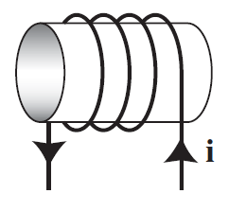
A coil with a current is shown above. In the center of the coil, a magnetic field points
a. | to the right.
b. | to the left.
c. | upward.
d. | downward.

ANS: B PTS: 1 STA: PH5.G NOT: Released 2005

86.
The diagram below shows current flow through a wire.
Which of the following represents the magnetic field resulting from the current?
a.
b. | 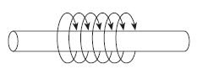
c.
d. | 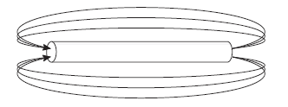

ANS: B PTS: 1 STA: PH5.G NOT: Released 2006

87. Students in a lab measure a current flowing through a long loop of wire.
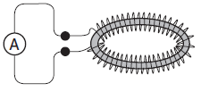
If there is no current source connected to the wire, which of the following explains the source of the current?
a. | The ammeter is acting as a current source.
b. | There is an oscillating magnetic field inside the loop.
c. | There is a fixed current running in a separate wire along the axis of the loop.
d. | There is a static configuration of positive charge external to the loop.

ANS: B PTS: 1 STA: PH5.H NOT: Released 2008

88.
In order to turn neon gas into neon plasma,
a. | energy must be removed from the neon gas.
b. | energy must be supplied to the neon gas.
c. | the neon gas must be ignited with a flame.
d. | the neon gas must become a superconductor.

ANS: B PTS: 1 STA: PH5.I NOT: Released 2004

89.
Extremely high temperatures are needed for fusion reactors to function efficiently. What state of matter is most common at these temperatures?
a. | plasma
b. | gas
c. | liguid
d. | solid

ANS: A PTS: 1 STA: PH5.I NOT: Released 2006

